**Assignment-7**

**(Events in JavaScript)**

**(Total: 100 points)**

**Learning Objectives**

* Hands-on practice on getting familiar with events such as click, keypress, focus, and blur.
* Hands-on practice on getting familiar with event handler, and how to registering event handler.

**Complete your assignment**

* Download the zip file named “**CS381_A7.zip**” and then unzip the zip file. In the unzipped folder (by default with name “CS381_A8”), you will find three folders: css, images, and js and four html files: **click.html**, **focus-blur.html, form.html, focus-blur_v2.html**. Take a look on each of those html and js files in text editor, and then open those pages in web browser and testing the web pages to see how js code handles different events.

**Part-1 [39 points]:** In this instruction and question sheet, type in your answers to list the names of events and the names of event handlers in each of those sample code, and provide explanations on what the event handlers (e.g., functions that are executed when event(s) occurs) do when the events occurs.

For example, in click.html and click.js, sample answers are as follows:

In click.html there is no HTML event attributes are used to register event and event handler.

In click.js, the events and event handlers’ registration statements are in line 17, lines 19-21, lines 22-24.

1. List the events: click, focus, and blur
2. List the event handlers used to handler those events are: dismissNote() function, the anonymous function defined in lines 19-20:  function () {   document.getElementById('username').value = "Input a user name here. ";    } and the anonymous function defined in lines 22-23  function () {     document.getElementById('username').value = "leave user name box. ";       }
3. What do the event handlers do? Explain each of them:

* dismissNote() function is used to response to the click event fires on the element node with id=’close’, which is the <a> element node added to DOM tree by the js code in lines 9 and 10 in this js program. When click event occurs, the dismissNote() function is executed to remove the <div> element with id=’note’ from DOM three.
* The anonymous function defined in lines 19-20 is the event handler responding to the focus event fires on the <input> element node with id=’username’. When that focus event occurs, the value of that <input> element will be updated, which will make web browser to display text content “Input a user name here.” in the <input> box.
* The anonymous function defined in lines 22-23 is the event handler responding to the blur event fires on the <input> element node with id=’username’. When that blur event occurs, the value of that <input> element will be updated, which will make web browser to display text content “leave user name box” in the <input> box.

**Type in your answers in the following questions:**

1. **[12pts] In focus-blur.html and focus-blur.js:**
2. List the events: (focus,blur,onLoad)
3. List the event handlers: (tipUsername(),checkUsername(), alert(“open focus-blur page”))
4. What do the event handlers do? Explain each of them.
   1. tipUsername() sets the messeges class to the tip class and makes it so that when it is clicked it displays the message “Username must be at least 5 characters”
   2. checkUsername() makes it so that if the username is not at least 5 characters long, it changes it displays the warning display error “Not long enough, yet...”
   3. alert() displays a pop up when the website is loaded that needs to be cleared to continue to the site with the message “open focus-blur page!”
5. **[15pts] In form.html and form.js:**
6. List the events: (submit,change)
7. List the event handlers: checkTerms() function and packageHint() function
8. What do the event handlers do? Explain each of them.
   1. checkTerms() looks to see if the check if the Terms and condition box has been checked, and if it does, it displays the inner html message determined by the packageHint() function.
   2. packageHint() checks to see which dialog box in the package drop down menu has been selected, if it is the “monthly one it sets elPackageHint.innerHtml to 'Save $10 if you pay for 1 year!' otherwise it is set too 'Wise choice!'.
9. **[12pts] In keypress.html and keypress.js:**
10. List the events: (keypress)
11. List the event handlers: (charCount)
12. What do the event handlers do? Explain each of them. (add your answer here)
    1. Attaches a keypress event listener to the html element text area “message” and runs the charCount function. This functions saves the entire users text and then a counter for how long the message is. It then will subtract the message length by 180 the max character limit to display how many characters are left, as well as displaying the last characters ASCII code below the length message.

**Part-2 [56 points]: Open focus-blur_v2.html and** **focus-blur_v2.js in a text editor and complete the following steps.** In focus-blur_ve.js,

**step 1: [15pts]Complete** **checkPassword()** function by adding js code. If user did not enter a password (i.e., password input box is empty, return false, otherwise, return true. [Hint: use length property to check password string, if length is 0, which indicates no password entered]

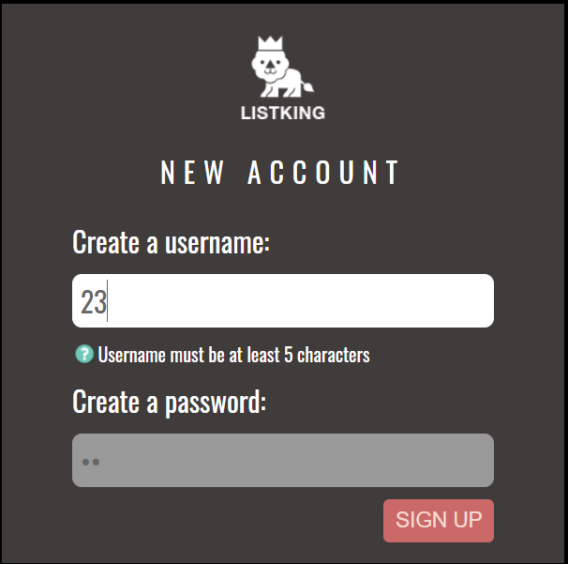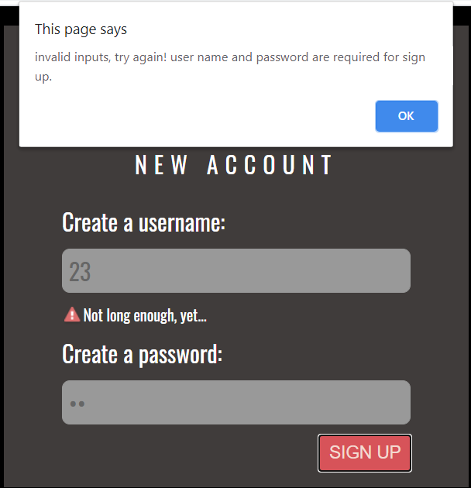**step 2: [15pts]Complete** **checkBeforeSubmit()** function by completing the if statement. If user enters invalid user name, or did not enter a password, then (1) use event object and preventDefault() method to prevent the submission of user name and password to the server side. (2) create a alert pop-up box and display a message: "invalid inputs, try again! user name and password are required for sign up." (3) use focus() method of DOM element object to make username input box focused.

**step 3: [15pts] use addEventListener method** to register event handler (i.e., checkBeforeSubmit function) to the <form> element for the ‘submit’ event.

**step 4: [11pts]** **Test and debug your program (you may use the developer tool in browsers help you) to make sure there is no syntax and logical errors. If there are some errors that you cannot figure out, please write a note in your program or leave a message in your dropbox.**

**Submit your assignment [5pts]**

* Type in your answers in this instruction and question sheet, and save it as a Word document. Zip all the files and folders in this assignment, and then rename the zipped file as “**CS381_A7_yourFirstNameLastName**” to the assignment drop boxnamed **“Assignment-7 (Week-9, events)”.**